DBMS LAB 5

V Venkataraman 106118106

Q1

use mysampldb;

DROP TABLE ORDERR;

DROP TABLE CUSTOMER;

CREATE TABLE ORDERR

(

OrderId INT PRIMARY KEY,

CustomerID INT,

OrderDate DATE

);

CREATE TABLE CUSTOMER

(

CustomerId INT PRIMARY KEY,

CustomerName VARCHAR(100),

ContactName VARCHAR(100),

Country VARCHAR(100)

);

-- 1)

INSERT INTO ORDERR

VALUES

(10308, 2, '1996-09-18'),

(10309, 37, '1996-09-19'),

(10310, 77, '1996-09-20'),

(10311, 4, '2019-02-20'),

(10312, 42, '2018-11-28'),

(10313, 3, '2012-03-12'),

(10314, 42, '2003-12-31'),

(10315, 6, '1998-05-14');

INSERT INTO CUSTOMER

VALUES

(1, 'Alfreds Futterkiste', 'Maria Anders', 'Germany'),

(2, 'Ana Trujillo Emparedados y helados', 'Ana Trujillo', 'Mexico'),

(3, 'Antonio Moreno Taqueira', 'Antonio Moreno', 'Mexico'),

(4, 'Balakumar Nair', 'Ranga Nair', 'India'),

(5, 'Akash Sharma', 'Anita Sharma', 'India'),

(6, 'Shreya Patel', 'Harsh Patel ', 'India'),

(7, 'Aditya Kumar', 'Dhruv Kumar', 'USA'),

(8, 'Rahul Pandey', 'Nicholas Pandey', 'USA');

-- 2)

SELECT *

FROM CUSTOMER INNER JOIN ORDERR ON CUSTOMER.CustomerId=ORDERR.CustomerId;

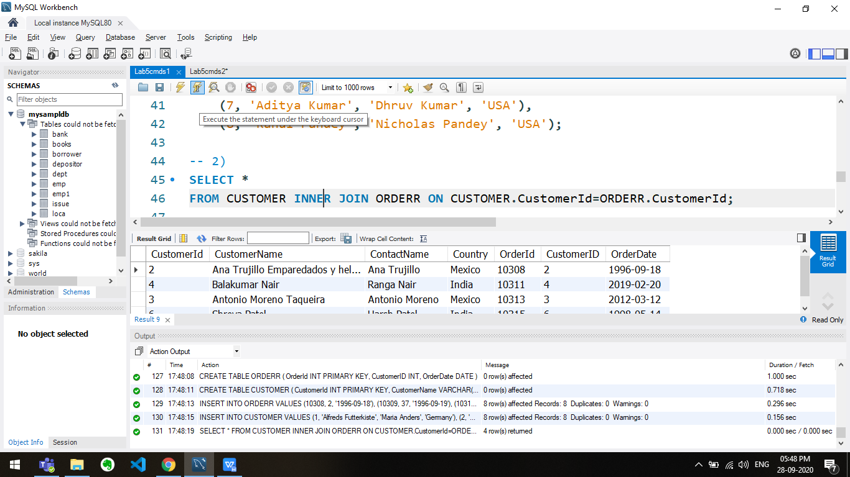

-- 3)

SELECT * FROM CUSTOMER LEFT OUTER JOIN ORDERR

ON CUSTOMER.CustomerId=ORDERR.CustomerId;

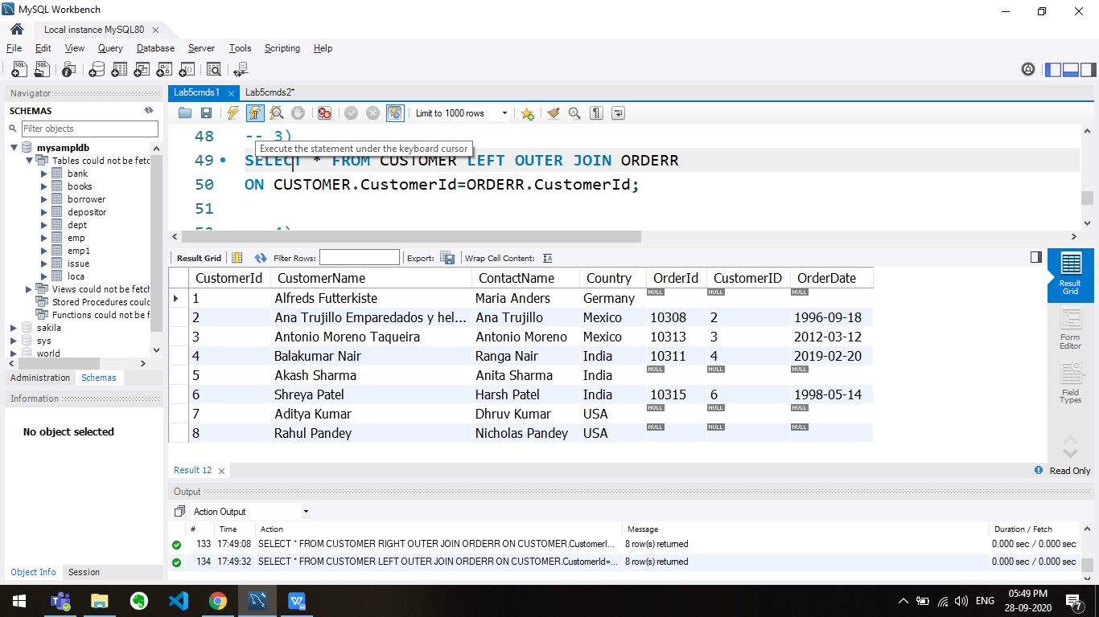

-- 4)

SELECT * FROM CUSTOMER RIGHT OUTER JOIN ORDERR

ON CUSTOMER.CustomerId=ORDERR.CustomerId;

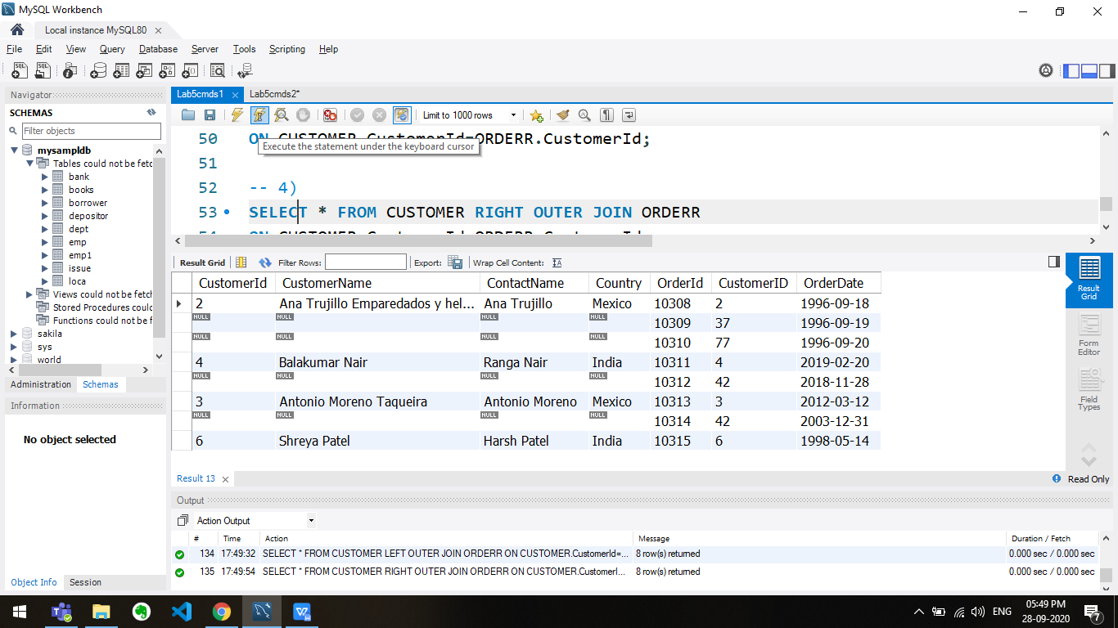

-- 5)

SELECT * FROM CUSTOMER LEFT OUTER JOIN ORDERR

ON CUSTOMER.CustomerId=ORDERR.CustomerId

UNION

SELECT * FROM CUSTOMER RIGHT OUTER JOIN ORDERR

ON CUSTOMER.CustomerId=ORDERR.CustomerId;

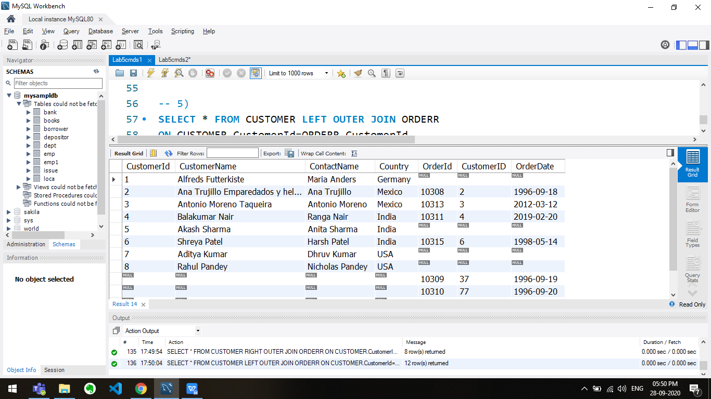

Q2

use mysampldb;

DROP TABLE Customer;

DROP TABLE Item;

DROP TABLE Sale;

CREATE TABLE Customer

(

Cust_id INT PRIMARY KEY,

cust_name VARCHAR(50)

);

CREATE TABLE Item

(

item_id INT,

item_name VARCHAR(50),

price INT

);

CREATE TABLE Sale

(

bill_no INT PRIMARY KEY,

bill_date DATE,

cust_id INT,

item_id INT,

qty_sold INT DEFAULT 0

);

INSERT INTO CUSTOMER VALUES

(101,'Ahmed'),

(102,'Bala'),

(103, 'Chan'),

(104, 'Dhruv'),

(105, 'Easwar'),

(106, 'Freddy'),

(107, 'Gayatri'),

(108, 'Harsh'),

(109,'Rahul'),

(110, 'Sam');

INSERT INTO Item VALUES

(1, 'T-Shirt', 999),

(2, 'Smartphone', 30000),

(3, 'Watch', 5000),

(4, 'Cap', 300),

(5, 'Trimmer', 3000),

(6, 'Comb', 100),

(7, 'Laptop', 60000),

(8, 'Gaming System', 200000),

(9, 'Headphones', 7000),

(10, 'Shoes', 2000);

INSERT INTO Sale VALUES

(8001, '2018-12-27',103, 4, 5),

(8002, '2019-01-15', 103, 2, 10),

(8003, '2019-02-07', 101, 3, 2),

(8004, '2019-04-13', 110, 5, 1),

(8005, '2019-06-27', 109, 7, 2),

(8006, '2019-08-07', 109, 7, 3),

(8007, '2019-10-17', 102, 6, 100),

(8008, '2019-12-07', 105, 8, 1),

(8009, '2020-09-28', 106, 8, 1),

(8010, '2020-09-28', 108, 8, 1);

-- b

CREATE VIEW Luxury_Items AS

(SELECT * FROM ITEM WHERE PRICE > 500);

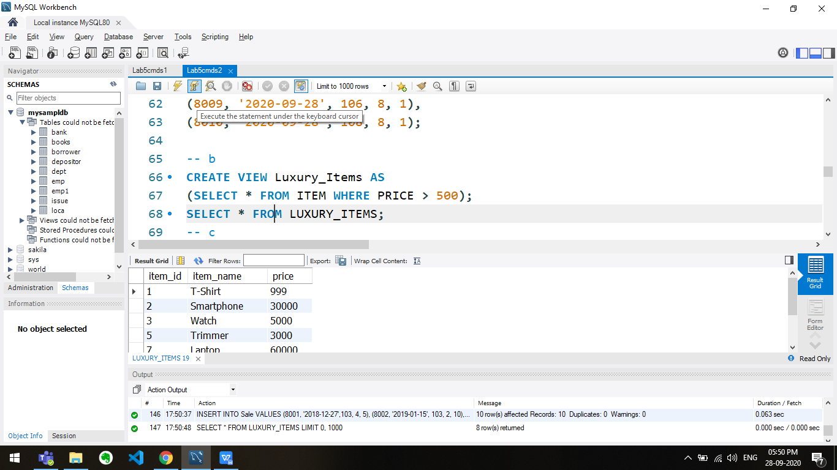

SELECT * FROM LUXURY_ITEMS;

-- c

UPDATE Luxury_Items SET PRICE = 250 WHERE ITEM_ID = 2;

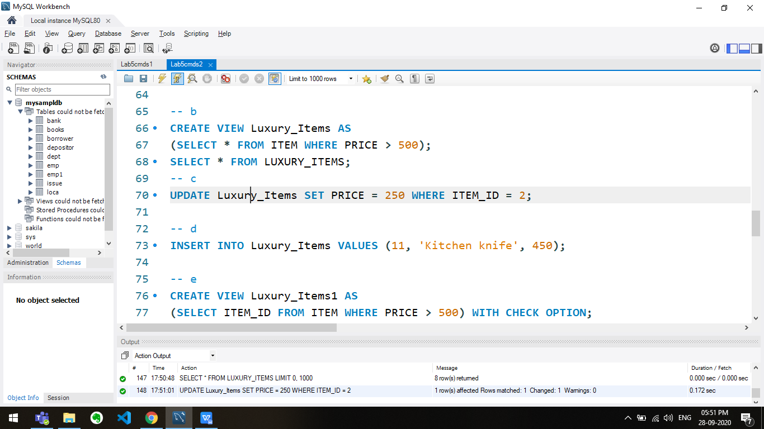

-- d

INSERT INTO Luxury_Items VALUES (11, 'Kitchen knife', 450);

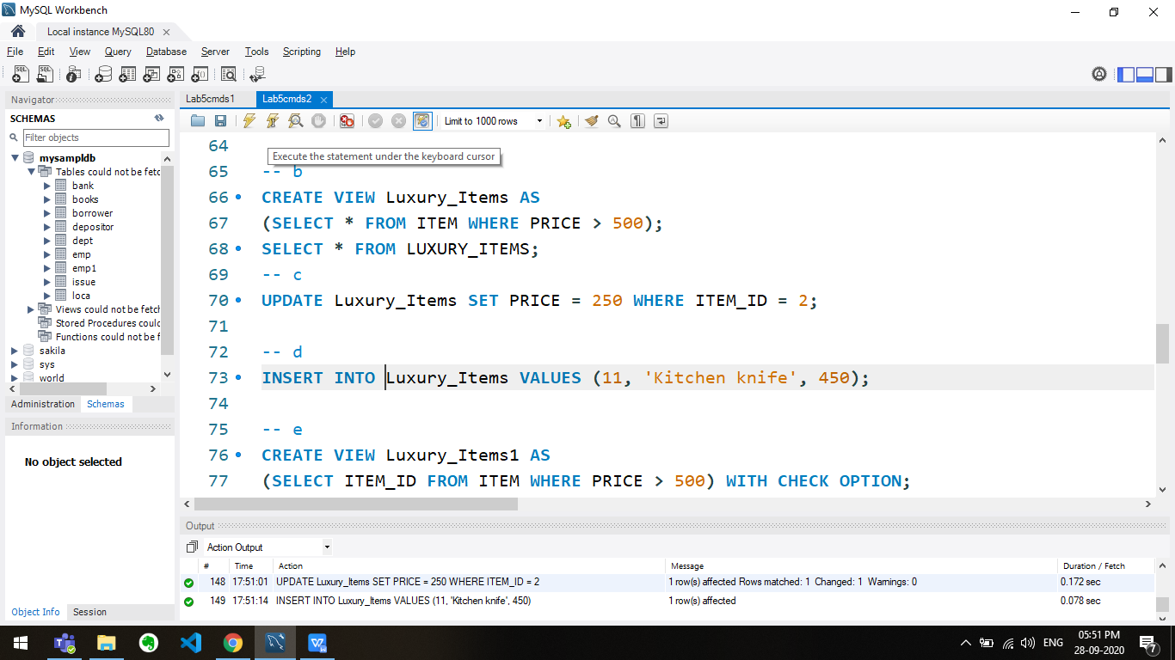

-- e

CREATE VIEW Luxury_Items1 AS

(SELECT ITEM_ID FROM ITEM WHERE PRICE > 500) WITH CHECK OPTION;

SELECT * FROM Luxury_Items1;

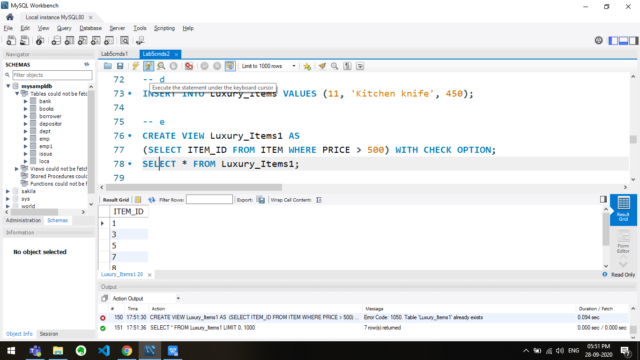

-- f

INSERT INTO Luxury_Items1 VALUES (11, 'Kitchen knife', 450);

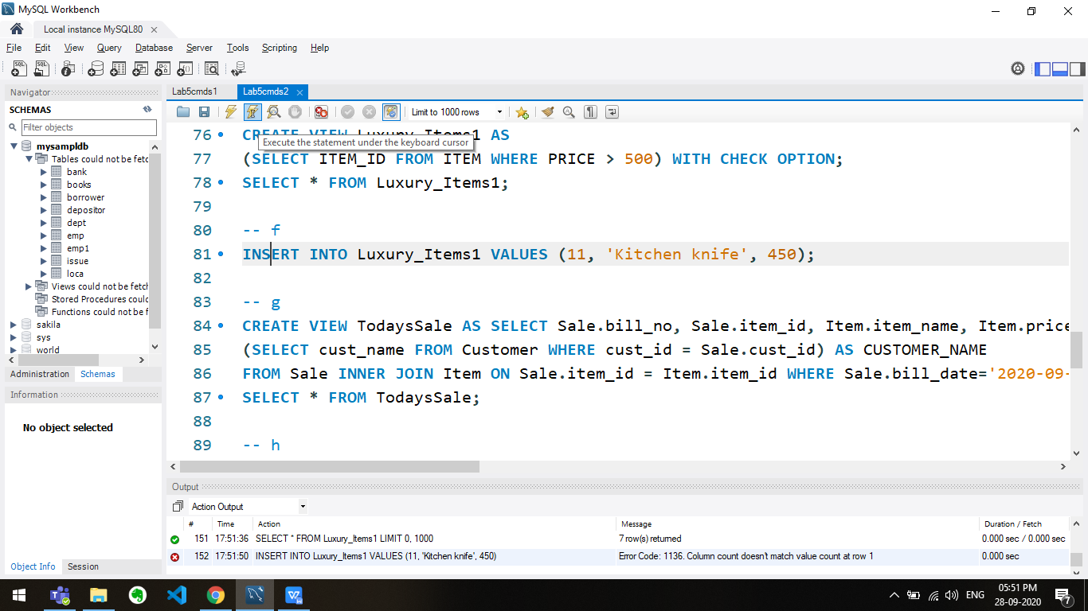

-- g

CREATE VIEW TodaysSale AS SELECT Sale.bill_no, Sale.item_id, Item.item_name, Item.price,

(SELECT cust_name FROM Customer WHERE cust_id = Sale.cust_id) AS CUSTOMER_NAME

FROM Sale INNER JOIN Item ON Sale.item_id = Item.item_id WHERE Sale.bill_date='2020-09-28';

SELECT * FROM TodaysSale;

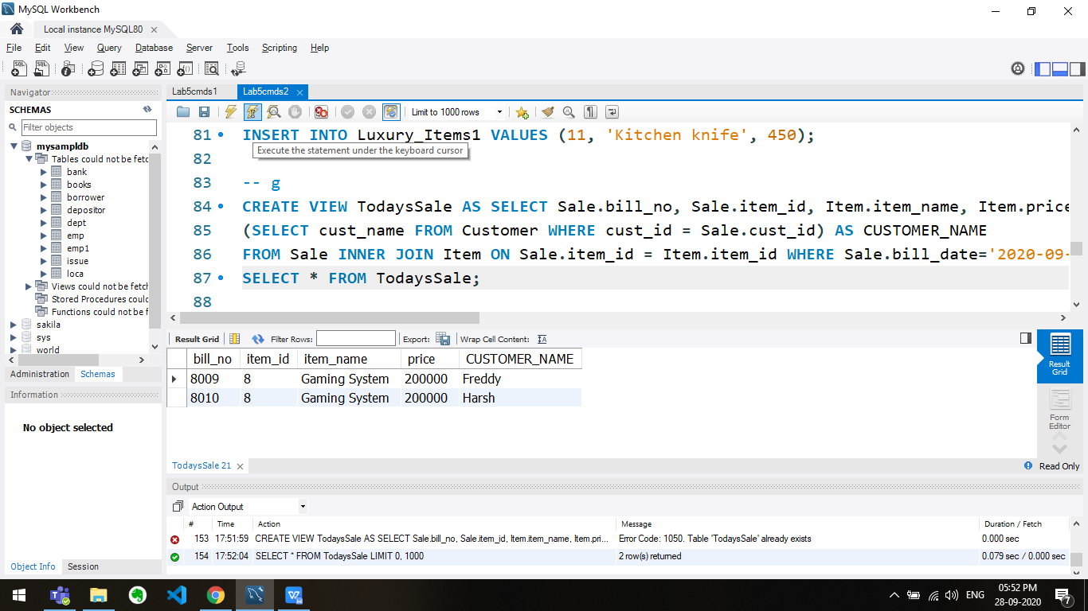

-- h

UPDATE TodaysSale SET PRICE = 900 WHERE item_id = 2;

-- i

CREATE VIEW I AS (SELECT CUSTOMER.CUST_NAME,SUM(QTY_SOLD) FROM CUSTOMER,SALE WHERE CUSTOMER.CUST_ID=SALE.CUST_ID GROUP BY SALE.CUST_ID);

SELECT * FROM I;

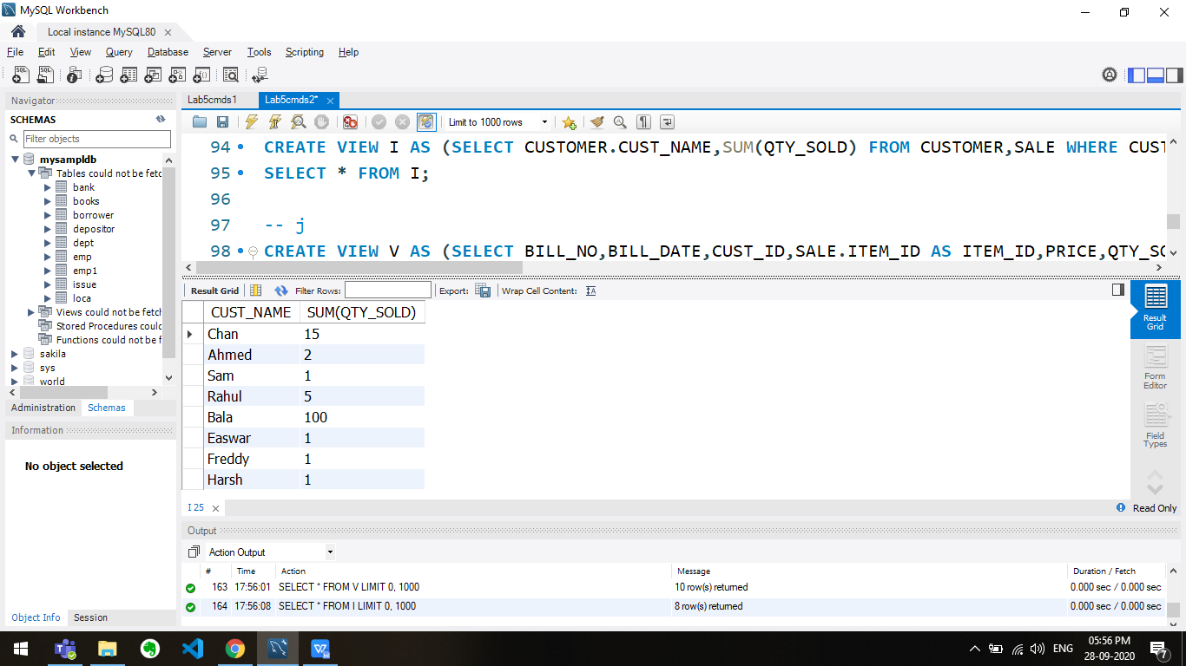

-- j

CREATE VIEW V AS (SELECT BILL_NO,BILL_DATE,CUST_ID,SALE.ITEM_ID AS ITEM_ID,PRICE,QTY_SOLD,(PRICE*QTY_SOLD) AS AMOUNT

FROM ITEM,SALE WHERE ITEM.ITEM_ID=SALE.ITEM_ID);

SELECT * FROM V;

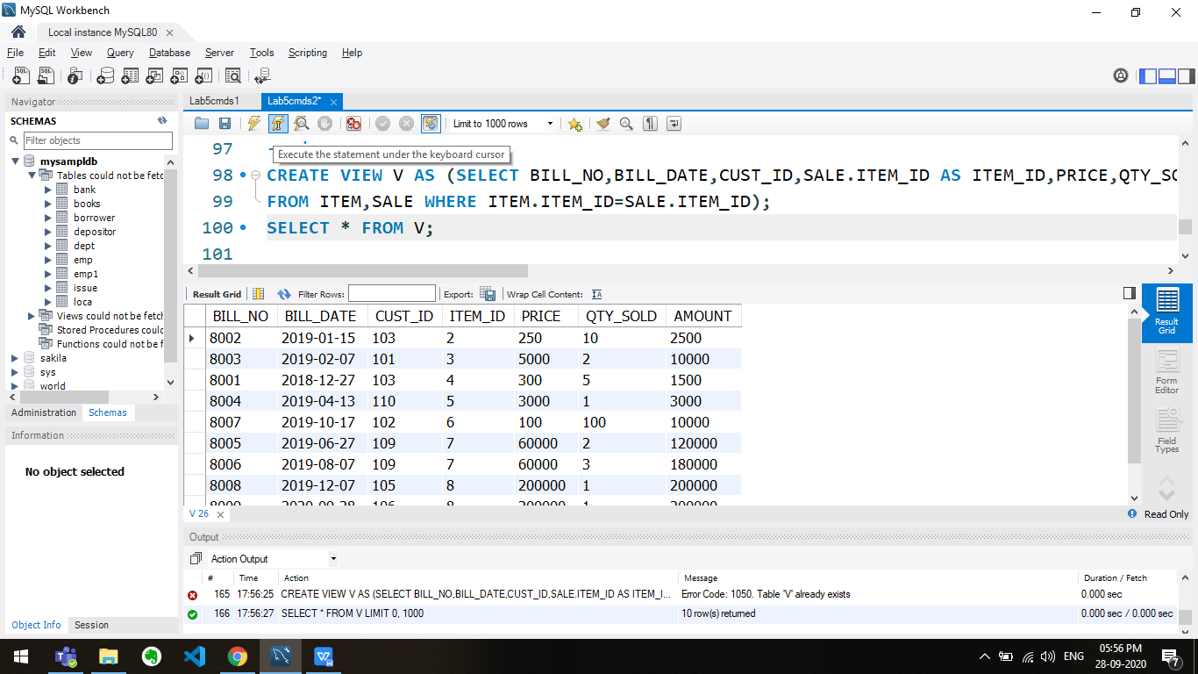

-- k

SELECT ITEM_NAME,SALES_REVENUE FROM

(SELECT ITEM_NAME,PRICE*QTY_SOLD FROM ITEM,SALE WHERE YEAR(BILL_DATE)='2019' GROUP BY ITEM_NAME) AS ITEM_SALES(ITEM_NAME,SALES_REVENUE)

ORDER BY SALES_REVENUE DESC LIMIT 5;

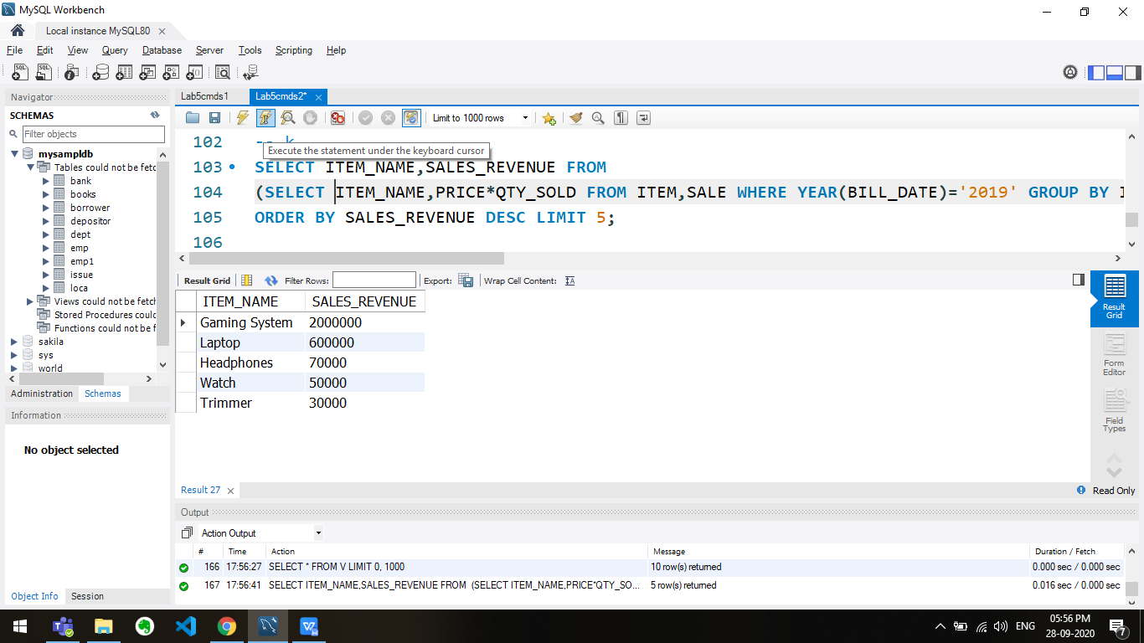

-- l

SELECT typeC, count(typeC) from(

SELECT CUST_ID,

case

when (SUM(QTY_SOLD * price) < 10000 ) then 'Silver'

when (SUM(QTY_SOLD * price) >= 10000 AND SUM(QTY_SOLD * price) < 50000) then 'Gold'

when (SUM(QTY_SOLD * price) > 50000 ) then 'Platinum'

end

as typeC

from SALE, ITEM

where SALE.ITEM_ID = ITEM.item_id

group by cust_id) AS cust_types

GROUP BY typeC;

